* Exploratory data analysis in PÇhon.

### Let us understand how to explore the data in python.



Image Credits: Morían

## Introduction

**What** is **Exploratory** Data Analysis ?

Exploratory Data Analysis or (EDA) is understanding the data sets by summarizing their main characteristics often plotting them visually. This step is very important especially when we arrive at modeling the data in order to apply Machine learning. Plotting in EDA consists of Histograms, Box plot, Scatter plot and many more. It often takes much time to explore the data. Through the process of EDA, we can ask to define the problem statement or definition on our data set which is very important.

**How to perform Exploratory Data Analysis** ?

This is one such question that everyone is keen on knowing the answer. Well, the answer is it depends on the data set that you are working. There is no one method or common methods in order to perform EDA, whereas in this tutorial you can understand some common methods and plots that would be used in the EDA process.

What data are we exploring today ?

Since I am a huge fan of cars, I got a very beautiful data-set of cars from Kaggle. The data-set can be downloaded from here. To give a piece of brief information about the data set this data contains more of 10, 000 rows and more than 10 columns which contains features of the car such as Engine Fuel Type, Engine HP, Transmission Type, highway MPG, city MPG and many more. So in this tutorial, we will explore the data and make it ready for modeling.

##### - Importing the required libraries for EDA

Below are the libraries that are used in order to perform EDA (Exploratory data analysis) in this tutorial.

import pandas as pd

import numpy as np import seaborn as sns

import matplotlib.pyplot as plt

%matplotlib inline

sns.set(cOlOr_codes=True)

#visualisation #visualisation



- 2. Loading the data into the data frame.

Loading the data into the pandas data frame is certainly one of the most important steps in EDA, as we can see that the value from the data set is comma-separated. So all we have to do is to just read the CSV into a data frame and pandas data frame does the job for us.

To get or load the dataset into the notebook, all I did was one trivial step. In Google Colab at the left-hand side of the notebook, you will find a > (greater than symbol). When you click that you will find a tab with three options, you just have to select Files. Then you can easily upload your file with the help of the Upload option. No need to mount to the google drive or use any specific libraries just upload the data set and your job is done. One thing to remember in this step is that uploaded files will get deleted when this runtime is recycled. This is how I got the data set into the notebook.

df = pd . rea d_c s v ( "data . c sv" ) # To display the top 5 rows d-F . h ea d ( 5)

Engine

Engine Engine Transmission

Number

Vehicle Vehicle

Make Model Year Fue1 Type

HP Cylinders Type

Driven_Wheels

of Market CategO y size Style Doors



1 premium

0 BMW Series 2011 unleaded 335.0

M (required)

Factory

* 1. MANUAL rear wheel drive 2.0 Tuner,Luxury, High- Compact Coupe

Performance

* + 1. BMW

1

Series

1

premium

2011 unleaded 300.0 (required)

premium

6.0 MANUAL rear wheel drive 2.0 Lumry,Performance Compact Convertible

Luxury,High-

* + 1. BMW

Series

2011 unleaded 300.0 (required)

ó.0 MANUAL rear wheel drive 2.0

Performance

Compact Coupe

df.tail(5)

na ke

l•iode1 Yeah

# To display the botton 5 rows

Engine Fue1 Engine Engine Transn1s s ion Type HP Cy1inders Type

|  |  |  |  |  |  |
| --- | --- | --- | --- | --- | --- |
|  | | | | Doors |  |
| 300.0 | 6.0 | AUTOMATIC | all wheel drive | 4.0 | Crossover,Hatchback,Luxury |
| 300.0 | 6.0 | AUTOMATIC | all wheel drive | 4.0 | Crossover,Hatchback,Lumry |
| 300.0 | 6.0 | AUTOMATIC | all wheel drive | 4.0 | Crossaver,Hatchback,Luxury |
| 300.0 | 6.0 | AUTOMATIC | all wheel drive | 4.0 | Crossover,Hatchback,Luxury |
| 221.0 | 6.0 | AUTOMATIC | front wheel drive | 4.0 | Luxury |

premium unleaded (required)

|  |  |  |  |
| --- | --- | --- | --- |
| 11909 | Acura | ZDX | 2012 |
| 11910 | Acura | ZDX | 2012 |
| 11911 | Acura | ZDX | 2012 |
| 11912 | Acura | ZDX | 2013 |
| 11913 | Lincoln | Zephyr | 2006 |

premium unleaded (required)

premium unleaded (required)

premium unleaded (recommended)

regular unleaded

Number

Driven_Nheels of

narket Category V'



## = 3. Checking the types of data

Here we check for the datatypes because sometimes the MSRP or the price of the car would be stored as a string, if in that case, we have to convert that string to the integer data only then we can plot the data via a graph. Here, in this case, the data is already in integer format so nothing to worry.

df.dtypes

object

Model object

Year int64

Engine Fuel Type object

Engine HP float64 Engine Cylinders float64 Transmission Type object Driven_Wheels object

Number of Doors float64

Market Category object

Vehicle Size object

Vehicle Style object

highway MPG int64

city mpg int64

Popularity int64

MSRP int64

dtype: object



## = 4. Dropping irrelevant columns

This step is certainly needed in every EDA because sometimes there would be many columns that we never use in such cases dropping is the only solution. In this case, the columns such as Engine Fuel Type, Market Category, Vehicle style, Popularity, Number of doors, Vehicle Size doesn't make any sense to me so I just dropped for this instance.

df - df.drop(['Engine Fuel Type', 'Market Category', 'Vehicle Style', 'Popularity', 'Number of Doors', 'Vehicle Size'], axis-1)

df.head (5)

|  |  |  |  |  |  |  |  |  |  |  |  |  |
| --- | --- | --- | --- | --- | --- | --- | --- | --- | --- | --- | --- | --- |
| Make | Model | Year | Engine HP | Engine | Cylinders | Transmission Type | Driven_Wheels | highway | MPG | city | mpg | MSRP |
| 0 BMW | 1 Series M | 2011 | 335.0 |  | 6.0 | MANUAL | rear wheel drive |  | 26 |  | 19 | 46135 |
| 1 BMW | 1 Series | 2011 | 300.0 |  | 6.0 | MANUAL | rear wheel drive |  | 28 |  | 19 | 40650 |
| 2 BMW | 1 Series | 2011 | 300.0 |  | 6.O | MANUAL | rear wheel drive |  | 28 |  | 20 | 36350 |
| 3 BMW | 1 Series | 2011 | 230.0 |  | 6.0 | MANUAL | rear wheel drive |  | 28 |  | 18 | 29450 |
| 4 BMW | 1 Series | 2011 | 230.0 |  | 6.0 | MANUAL | rear wheel drive |  | 28 |  | 18 | 34500 |



#### - 5. Renaming the columns

In this instance, most of the column names are very confusing to read, so I just tweaked their column names. This is a good approach it improves the readability of the data set.

df = df.rename(columns={"Engine HP": “HP“, “Engine Cylinders“ : ”Cylinders“, “Transmission Type“ : “Transmission“, ”Driven_Wheels"

dT. head ( 5)

09/12/2021 11:^9 Cópia de Exploratorydata Analysis.ipynb - ColaLoratory

|  |  |  |  |  |  |  |  |  |  |  |  |  |
| --- | --- | --- | --- | --- | --- | --- | --- | --- | --- | --- | --- | --- |
| Make | |  | Model | | Year | HP | Cylinders | Transmission | Drive Mode | MPG-H | MPG-C | Price |
| 0 BMW | | 1 | Series M | | 201 1 | 335.0 | 6.0 | MANUAL | rear wheel drive | 26 | 19 | 46135 |
| 1 | BMW | 1 | | Series | 2011 | 300.0 | 6.0 | MANUAL | rear wheel drive | 28 | 19 | 40650 |
| 1 | BMW | 1 | | Series | 2011 | 300.0 | 6.0 | MANUAL | rear wheel drive | 28 | 20 | 36350 |
| 3 | BMW | 1 | | Series | 2011 | 230.0 | 6.0 | MANUAL | rear wheel drive | 28 | 18 | 29450 |



# - 6. Dropping the duplicate rows

This is often a handy thing to do because a huge data set as in this case contains more than 10, 000 rows often have some duplicate data which might be disturbing, so here I remove all the duplicate value from the data-set. For example prior to removing I had J 191 4 rows of data but after removing the duplicates 1 0925 data meaning that I had 989 of duplicate data.

df.shape

(11914, 10)

duplicate_rows_df = df[df.duplicated()]

print(”number of duplicate rows: ", duplicate_rows_df.shape)

number of duplicate rows: (989, 1B)

###### Now let us remove the duplicate data because it's ok to remove them.

df.count() # Used to count the number of rows

Make 11914

https://coIab.research.gooqle.com/drive/1BJvMdu0uXFQJlAlOkM7ynkWèzhdF3XtH scroIITo—mhA_0CQOTDOy&printMoJe—true 8/1B

|  |  |
| --- | --- |
| Model | 11914 |
| Year | 11914 |
| HP | 11845 |
| Cylinders | 11884 |
| Transmission | 11914 |
| Drive Mode | 11914 |
| NPG-H | 11914 |
| NPG-C | 11914 |
| Price | 11914 |
| dtype: int64 |  |

So seen above there are 11914 rows and we are removing 989 rows of duplicate data.

df = df.drop_duplicates() df.head (5)

|  |  |  |  |  |  |  |  |  |  |  |
| --- | --- | --- | --- | --- | --- | --- | --- | --- | --- | --- |
|  | Make | Model | Year | HP | Cylinders | Transmission | Drive Mode | MPG-H | MPG-C | Price |
| 0 | BMW | 1 Series M | 2011 | 335.0 | 6.0 | MANUAL | rearwheel drive | 26 | 19 | 46135 |
| 1 | BMW | 1 Series | 2011 | 300.0 | 6.0 | MANUAL | rearwheeldrive | 28 | 19 | 40650 |
| 1 | BMW | 1 Series | 2011 | 300.0 | 6.0 | MANUAL | rearwheeldrive | 28 | 20 | 36350 |
| 3 | BMW | 1 Series | 2011 | 230.0 | 6.0 | MANUAL | rear wheeldrive | 28 | 18 | 29450 |
| 4 | BMW | 1 Series | 2011 | 230.0 | 6.0 | MANUAL | rear wheeldrive | 28 | 18 | 34500 |

df.count()

|  |  |
| --- | --- |
| Make | 10925 |
| Model | 10925 |
| Year | 10925 |
| HP | 10856 |
| Cylinders | 10895 |
| TransmlSsion | 10925 |
| Drive Mode | 10925 |
| MPG-H | 10925 |

|  |  |  |
| --- | --- | --- |
| MPG - C |  | 10925 |
| Price  dtype: | int64 | 10925 |



= 7. Dropping the missing or null values.

This is mostly similar to the previous step but in here all the missing values are detected and are dropped later. Now, this is not a good approach to do so, because many people just replace the missing values with the mean or the average of that column, but in this case, I just dropped that missing values. This is because there is nearly 10D missing value compared to 10, 000 values this is a small number and this is negligible so I just dropped those values.

print(df.isnull().sum())

|  |  |
| --- | --- |
| Make | 0 |
| Model | 0 |
| Year | 0 |
| HP | 69 |
| Cylinders | 30 |
| Transmission | 0 |
| Drive Mode | 0 |
| MPG-H | 0 |
| MPG-C | 0 |
| Price  dtype: int64 | 0 |

This is the reason in the above step while counting both Cylinders and Horsepower (HP) had 10856 and 10895 over 109Z5 rows.

df = df.dropna() # Dropping the missing values. df.count()

|  |  |
| --- | --- |
| Make | 10827 |
| Model | 10827 |
| Year | 10827 |
| HP | 10827 |
| Cylinders | 10g27 |
| Transmission | 10827 |
| Drive Mode | 10827 |
| MPG-H | 10827 |
| MPG-C | 10827 |
| Price | 10827 |
| dtype: int64 |  |

Now we have removed all the rows which contain the Null or N/A values (Cylinders and Horsepower (HP)).

print(df.isnull().sum()) # After dropping the values Make O

Model O

Year 0

HP 0

Cylinders O

Transmission O

Drive Mode 0

MPG-H 0

MPG-C 0

Price 0

dtype: int64



- 8. Detecting Outliers

An outlier is a poínt or set of points that are different from other points. Sometimes they can be very high or very low. It's often a good idea to detect and remove the outliers. Because outliers are one of the primary reasons for resulting in a less accurate model. Hence it's a good idea to remove them. The outlier detection and removing that I am going to perform is called IQR score technique. Often outliers can be seen with visualizations using a box plot. Shown below are the box plot of MSRP, Cylinders, Horsepower and EngineSize. Herein all the plots, you can find some points are outside the box they are none other than outliers. The technique of finding and removing outlier that I am performing in this assignment is taken help of a tutorial from towards data science.

sns.boxplot(x=df['Price'])

<matplotlib.axes._subplots.AxesSubplot at 0x7f0d36a38be0›



0 500000 1000000 1500000 2000000

i rice

sns.boxplot(x=df['HP'])

<matplotlib.axes._subplots.AxesSubplot at 0x7f0d369b3ba8›

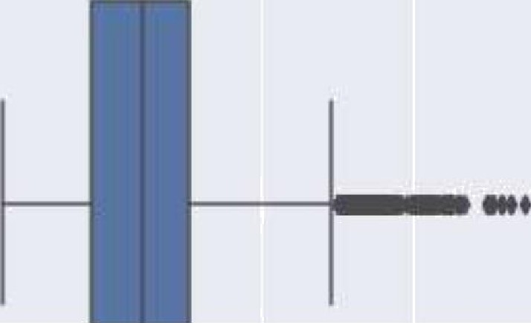

sns.boxplot(x=df[’Cylinders'])

<matplotlib.axes._subplots.AxesSubplot at 0x7f0d34l3ff28›

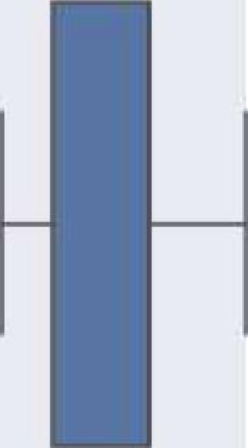

0 2 4 +J B 10 12 U 16

Cyfinders

Q1 = df.quantile(0.25) Q3 = df.quantile(0.75) IQR = Q3 - Q1

print(IQR)

|  |  |
| --- | --- |
| Year | 9.0 |
| HP | 130.0 |
| Cylinders | 2.0 |

|  |  |  |
| --- | --- | --- |
| 09/12/2021 11:^9 |  | Cópia de Exploratorydata Analysis.ipynb - ColaLoratory |
| MPG-H | 8.0 |  |
| MPG-C | 6.0 |  |
| Price  dtype: | 21327.5  f1oat64 |  |

Don't worry about the above values because it's not important to know each and every one of them because it's just important to know how to use this technique in order to remove the outliers.

df = df[-((df ‹ (Q1 - 1.5 * IQR)) |(df › (Q3 + 1.5 * IQR))).any(axis=1)] df.shape

( 9191, l B)

As seen above there were around 1600 rows were outliers. But you cannot completely remove the outliers because even after you use the above

technique there maybe 1—2 outlier unremoved but that ok because there were more than 100 outliers. Something is better than nothing.



# - 9. Plot different features against one another (scatter), against frequency (histogram)

##### = Histogram

###### Histogram refers to the frequency of occurrence of variables in an interval. In this case, there are mainly 1 0 different types of car manufacturing companies, but it is often important to know who has the most number of cars. To do this histogram is one of the trivial solutions which lets us know the total number of car manufactured by a different company.

df.Make.value_counts().nlargest(40).plot(kind=' bar', figsize=(10,5)) plt.title("Number of cars by make“)

plt.ylabel('Number of cars') plt.xlabel('Make');

Number of Cars by make

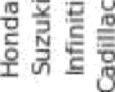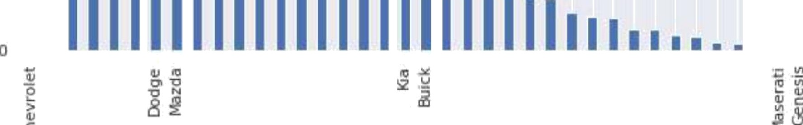

I0U0

6W0

400

200

Number of cars

##### - Heat Maps

P r' cedes

Make

Ford Toyota Volkswagen ssan 8MWSubaru BenzLexus SaabsdsmobileRover RAT Rymouth LotusMmRo

ł tsubishiChrysler- PontiacLincoln Porsche R

ø

/•g

C

Land

Alfa

###### Heat Maps is a type of plot which is necessary when we need to find the dependent variables. One of the best way to find the relationship between the features can be done using heat maps. In the below heat map we know that the price feature depends mainly on the Engine Size, Horsepower, and Cylinders.

plt.figure(figsize=(10,5))

c= df.corr() sns.heatmap(c,cmap=“BrBG",annot=True) C

|  |  |  |  |  |  |  |
| --- | --- | --- | --- | --- | --- | --- |
|  | Yea r | HP | Cylinders | MPG-H | MPG-C | Price |
| Ye ar | 1.000000 | 0.326726 | -0.133920 | 0.378479 | 0.338145 | 0.592983 |
| HP | 0.326726 | 1.000000 | 0.715237 | -0.443807 | -0.544551 | 0.739042 |
| Cylinders | -0.133920 | 0.715237 | 1.000000 | -0.703856 | -0.755540 | 0.354013 |
| M PG-H | 0.378479 | -0.443807 | -0.703B56 | 1.000000 | 0.939141 | -0.106320 |
| M PG-C | 0.338145 | -0.544551 | -0.755540 | 0.939141 | 1.000000 | -0.180515 |
| Price | 0.5929B3 | 0.739042 | 0.354013 | -0.106320 | -0.180515 | 1.000000 |

Year



Cylinders





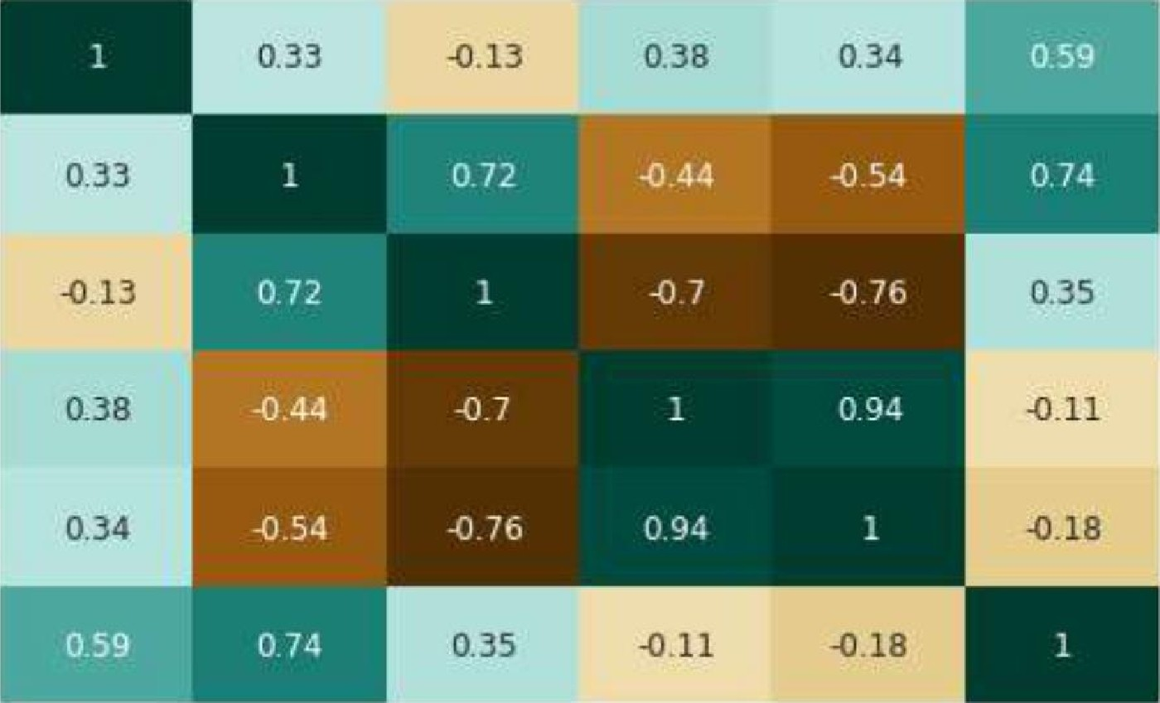Year f-P Cylinders ING-H ING-C

09

0.6



- 0.3

-00

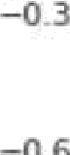

- Scatterplot

We generally use scatter plots to find the correlation between two variables. Here the scatter plots are plotted between Horsepower and Price and we can see the plot below. With the plot given below, we can easily draw a trend line. These features provide a good scattering of points.

fig, ax = plt.subplots(figsize=(1B,6))

ax.scatter(df[’HP’], df['Price']) ax.set xlabel(’HP’) ax.set_ylabel(’Price')

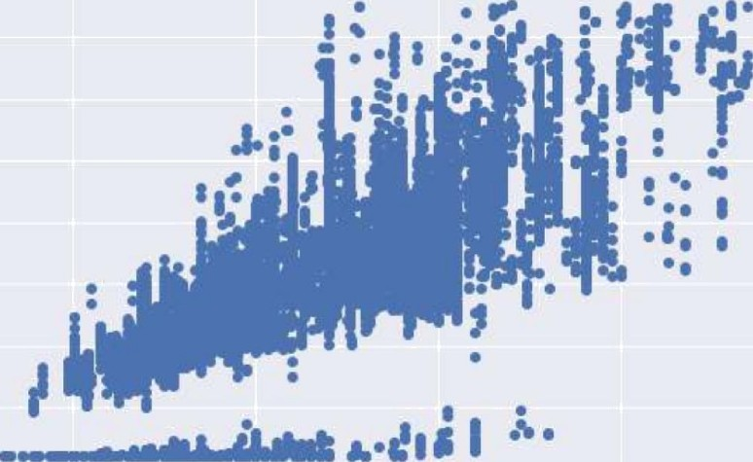plt.show()





40 0 00

3g 0 00

2L* 0 00

LO 000

10 0 200

HP

400 ?O0

Hence the above are some of the steps involved in Exploratory data analysis, these are some general steps that you must follow in order to perform EDA. There are many more yet to come but for now, this is more than enough idea as to how to perform a good EDA given any data sets. Stay tuned for more updates.

##### Thank you.